SMAANZ-CAUTHE 2018 HDR Conference Program – Friday 20th July 2018
The SMAANZ-CAUTHE 2018 HDR conference will take place at University of Queensland, St Lucia campus, Brisbane. We will be located in building ‘General Purpose North 3 (39A)’, within rooms 39A-208, 39A-201 and 39A-202 (see last page for map). The venue will be available from 8.30am, so please arrive early as there will be a prompt 9am start.

Time | Activity
9-9.30am | Welcome and introduction  Location: 39A-208  Board/Executive members: Judith Mair (CAUTHE Chair), Clare Hanlon (SMAANZ Chair), Katherine Raw (SMAANZ Student Representative)
9.30-10.30am | Presentations (3x20min: 10min presentation and 10min feedback)  - Peita Hillman (Southern Cross University): Identifying social psychological drivers behind the initiative to participate in active leisure events amongst previously inactive Australian adults  - Sabrina Seeler (Auckland University of Technology): Lost in translation: The conceptual meanings of the term ‘experience’  - James White (University of Canberra): Understanding the drivers of engagement and disengagement in participation sport  Location: 39A-201  Board/Executive members: Clare Hanlon, Marianna Sigala | Presentations (3x20min: 10min presentation and 10min feedback)  - Lloyd Rothwell (University of Technology Sydney): Leadership Development and Succession Management Practices in Australian Sporting Organisations  - Giang Hoang (Victoria University): Leadership and innovation tourism SMEs: The mediating roles of climate for innovation  - Beverly Chen (Auckland University of Technology): Gender metaphors in visual images of chefs  Location: 39A-202  Board/Executive members: Lisa Gowthorp, Noel Scott
10.30-11am | Morning tea  Location: 39A-208
11-12pm | Presentations (4x20min: 10min presentation and 10min feedback)  - Holly Thompson (University of Queensland): “If I was sitting next to an under 18 I’d offer him a beer”: minors’ alcohol-related behaviour in community sport clubs  - Tin Doan (Auckland University of Technology): Perception of multiple stakeholders about employability of people with disabilities in the Vietnamese hospitality industry  - Stirling Sharpe (University of Canberra): Abusing the third team; social norms that present unacceptable identities  Location: 39A-201  Board/Executive members: Katie Rowe, Wendy Hillman | Presentations (3x20min: 10min presentation and 10min feedback)  - Lizette Olivier (University of Newcastle): Examining Customer Perceived Value and its Consequences in Periodic Hallmark Events  - David Fechner (Griffith University): Sponsoring charity sport events to form meaningful relationships with external audiences  - Gurmeet Matharu (Southern Cross University): Factors influencing buying behavior of organic food products: An empirical study of young consumers in India  Location: 39A-202  Board/Executive members: Millicent Kennelly, Judith Mair
12-1pm | Lunch  Location: 39A-208
1-2pm | Presentations  (3x20min: 10min presentation and 10min feedback)  - Samira Zare (James Cook University): Knowledge emotions and tourism; what surprises, confuses or interests you in a trip to Iran?  - Greg Joachim (University of Technology Sydney): Generating Improved Innovation in Sport Management with Design Thinking  - Nina Dhirasasna (Griffith University): A System Approach to Understand Renewable Energy Technology Adoption in the Tourist Accommodation Sector in Queensland, Australia  Location: 39A-201  Board/Executive members: Michael Naylor, Kirsten Holmes | Presentations  (3x20min: 10min presentation and 10min feedback)  - Michelle Hayes (Griffith University): Social media and performance: Athlete perceptions of support mechanisms  - Sarah Wymer (Massey University): Facebook Live Streaming Reach, Engagement & Fan Motives: The Case of the Queensland Maroons  - Rui Zhang (Griffith University): Changing image schema of the beach destination through storytelling: a study of Hainan Island, China  Location: 39A-202  Board/Executive members: Ashleigh-Jane Thompson, Adam Karg, Kylie Radel
2-2.30pm | Break before Panel session
2.30-3.45pm | Panel session  “Research impact: Communicating your findings and getting these implemented into practice”:  - Prof Sara Dolnicar (facilitator) https://www.business.uq.edu.au/staff/sara-dolnicar  - Prof Noel Scott https://experts.griffith.edu.au/academic/noel.scott  - Prof Philip Pearce https://research.jcu.edu.au/portfolio/philip.pearce/  - Dr Richard Buning https://www.business.uq.edu.au/staff/richard-buning  Location: 39A-208  Board/Executive members: Leonie Lockstone-Binney, Katherine Raw
3.45-4pm | Conclusion and close  Location: 39A-208  Board/Executive members: Kirsten Holmes, Katherine Raw
4-5pm | Afternoon tea  Location: 39A-208
5pm onwards | Social event  - Pig and Whistle, Riverside, 123 Eagle Street, Brisbane  - Travel to the Pig and Whistle together after the day has finished. Drink and food are as you wish but costs will be covered by individuals themselves. For more information on the venue see: http://pignwhistle.com.au/riverside/about-us
Travelling to campus: We recommend attendees travel to campus by public transport (bus or City Cat). If driving, we suggest you arrive on campus prior to 9am to secure a carpark.

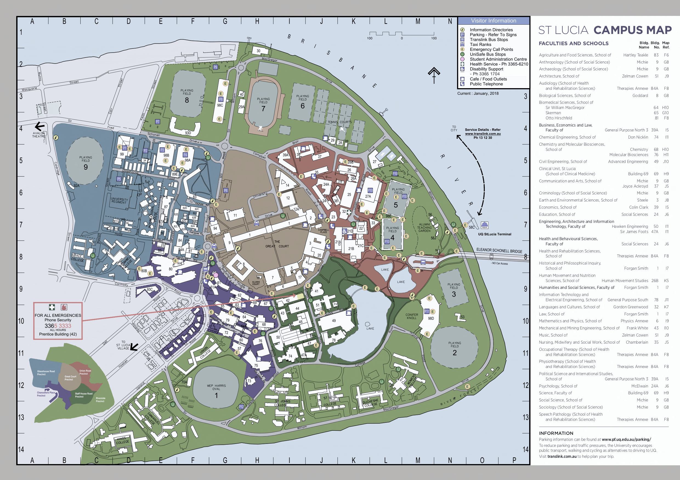
2018 HDR Conference location

