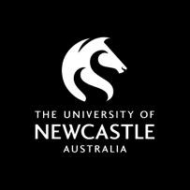

**CAUTHE 2018**

**Get Smart: Paradoxes & Possibilities in Tourism,**

**Hospitality & Events**

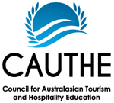

# Table of Contents

Introduction and Summary 3

Letters of Recommendation 4

Conference Host 8

Conference Committees 11

Conference Timing 11

Conference Theme 12

Inclusion and Accessibility 14

Conference Venue: The University of Newcastle 16

Conference Location: Newcastle 17

Transport and Transfers 18

Accommodation 20

Attractions and Activities 21

Conference Program 24

Environmental Impacts 28

Finance and Administration 29

Conference Budget 32

Promotion and Website 34

Registration and Attendee Management 35

Timeline: Steps and Milestones 36

Contact 37

# Introduction and Summary

The University of Newcastle is delighted to present a bid to host the 28th Annual Council of Australasian University and Hospitality Education (CAUTHE) Conference in February 2018. The University of Newcastle will host this conference in partnership with Newcastle City Council, Newcastle Business Events, Newcastle NOW and the Newcastle Tourism Industry Group.

The Tourism Discipline in the Newcastle Business School, Faculty of Business and Law, will lead CAUTHE 2018. The conference planning and scientific committees are comprised of academic staff in the Newcastle Business School together with scholars invited from other institutions.

The leadership team is as follows:

* Conference Convenor: Dr Tamara Young, Newcastle Business School
* Chair of the Scientific Committee: Professor Kevin Lyons, Newcastle Business School
* Conference Organiser: Kate Ramzan-Levy, Faculty of Business and Law
* Conference Planning Team: Dr Paul Stolk, Dr Patricia Johnson, Dr Anne Buchmann, Dr Po-Hsin Lai, Associate Professor Frank Agbola, and Dr Jamie Carlson

The proposed theme for CAUTHE 2018 is ***Get Smart: Paradoxes and Possibilities in Tourism, Hospitality and Event Studies***. At this conference we take inspiration from the Newcastle story and focus a lens on smart tourism in its broadest sense. A central question underpinning this conference theme is: How does tourism get smart? Specifically, how does tourism generate, employ and rely on knowledge? The CAUTHE 2018 conference will provide a forum to explore and debate how knowledges are transmitted in tourism, hospitality and events. The conference encourages a critical lens to consider the barriers of accessing such knowledge.

The proposed venue for CAUTHE 2018 is the NeW Space City Precinct Campus. NeW Space is a landmark education precinct located in the heart of Newcastle. Newcastle is Australia’s seventh largest and second oldest city, and boasts modern and contemporary venues along with iconic and historically significant function spaces. Located on the coast of New South Wales, only 160 kilometres north of Sydney, Newcastle is accessible by car or train from Sydney, or through direct flights from Sydney, Melbourne, Brisbane and the Gold Coast.

CAUTHE 2018 will commence with the PhD/ECR and MCA workshops on Monday 5th February, 2018. The main conference will follow from Tuesday 6th February to Thursday 8th February. Registration fees include full, student and single day registrations. CAUTHE members will receive a discounted CAUTHE members rate and an early bird discount will also be available. Postgraduate students will receive a discounted registration. All social events will be included in the registration fee although a separate fee for partner attendance will apply.

# Letters of Recommendation

This bid for CAUTHE 2018 has full support from the Faculty of Business and Law at the University of Newcastle, as well as support from Newcastle City Council and the Newcastle Tourism Industry. These letters of recommendation are provided on the following pages.

**Professor Richard Dunford**

Pro-Vice Chancellor, Faculty of Business and Law, The University of Newcastle.

**Councillor Nuatali Nelmes**

Lord Mayor of Newcastle, Office of the Lord Mayor, City Hall Newcastle.

**Mr Matt Anderson**

Chair of the Newcastle Tourism Industry Group.

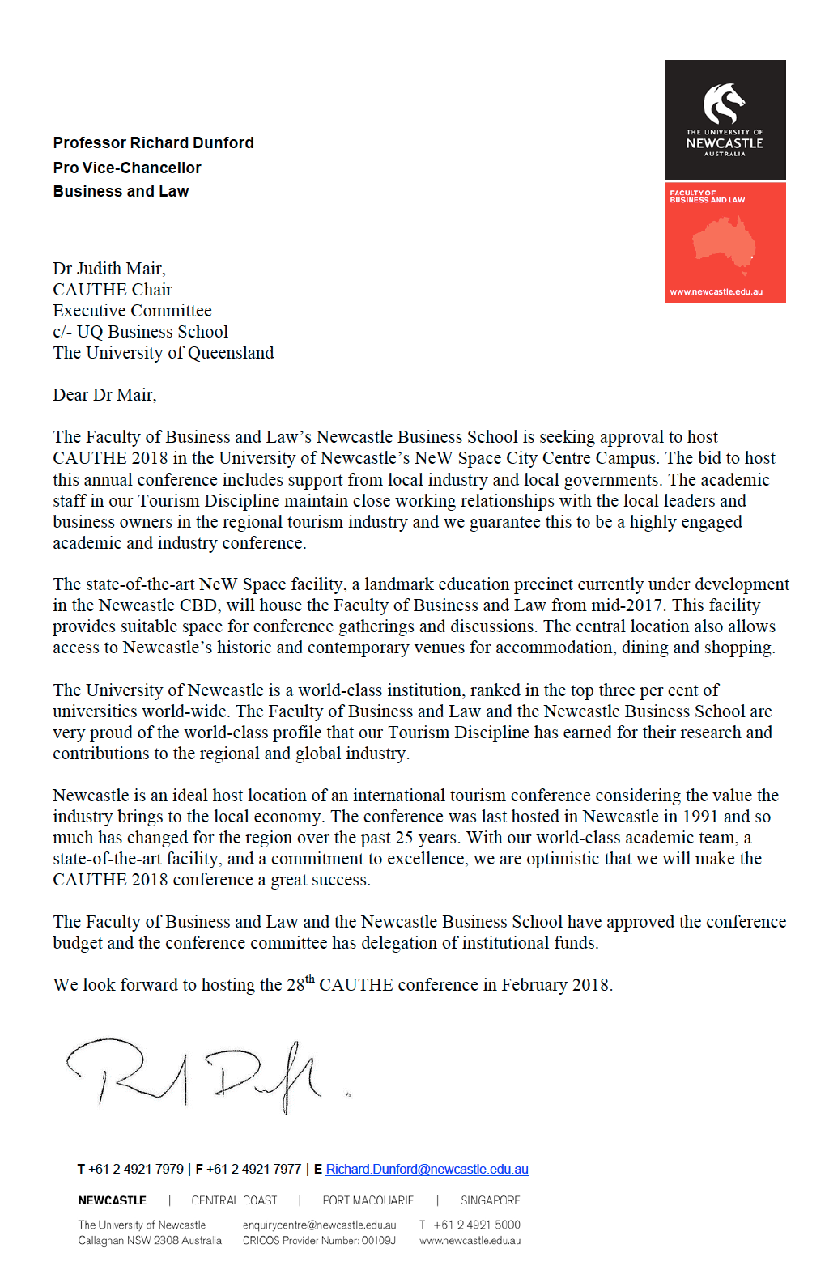

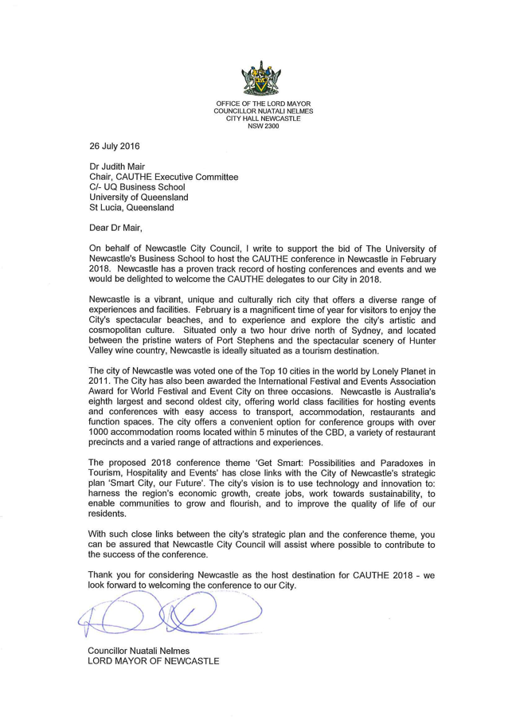

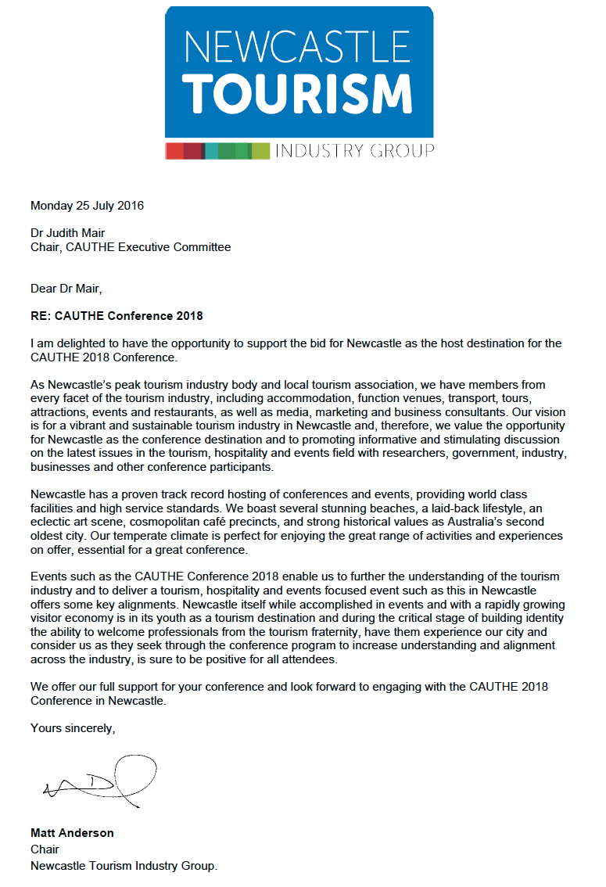

# Conference Host

**The University of Newcastle, Australia**

The University of Newcastle (UON) is ranked in the top 3% of the world’s universities (Times Higher Education World University Rankings 2015 and QS World University Rankings 2015). With eleven campuses across Australia and Asia, UON is recognised a as a global leader in research, innovation teaching and learning. UON currently has approximately 40,000 students from over 100 countries enrolled in various undergraduate and postgraduate degree programs. A commitment to equity has seen UON emerge as the largest provider of enabling programs in Australia, with 24% of our students from low socio-economic backgrounds. UON is at the forefront of Indigenous education, with the largest Indigenous student cohort in Australia.

**The Faculty of Business and Law**

Within the Faculty of Business and Law, our mission statement is to provide an innovative and dynamic learning community that offers leading-edge degrees and, in collaboration with our external partners and stakeholders, strives to ‘make a difference’ by creating new knowledge, preparing our students for global citizenship, and contributing to the progress of Australia and the Asia-Pacific region.

Our courses and degrees are cutting-edge and innovative, offering our students the opportunity to collaborate with business, government and the professions in work-integrated learning. All of our degrees and majors ensure that our students are equipped with the work-ready skills, such as critical thinking and problem solving, teamwork and advanced communication skills, sought by employers. We expect all our students to be leaders and global citizens, with a commitment to making a difference to Australia and the world.

Our academic staff members are committed educators and researchers, offering cutting-edge courses and engaging in collaborative learning with our students. Many of our lecturers have previous business and legal experience, bringing real-world experience to their teaching.

**Newcastle Business School**

In the Newcastle Business School, our mission is to build and sustain a vibrant learning community that advances business knowledge. In working to achieve our mission, we pursue:

* Opportunity for academic development that builds our research capabilities, both within disciplines and across disciplinary boundaries;
* Collaboration with local, national and international partners; and
* Research-led and student-focused teaching and learning opportunities

The Newcastle Business School is the University of Newcastle's centre for undergraduate, postgraduate and community business education. We focus on student-centred, research-driven teaching to develop the skills and attributes needed to sustain a successful career that is based on life-long learning.

The Newcastle Business School offers unique opportunities to become a skilled professional and enlightened citizen by encountering new ideas, establishing new networks, and identifying future opportunities.

As well as their discipline-based content and professional expertise, our academics emphasise communication, independent study skills, awareness of cultural differences, and activities to foster powers of analysis and creativity.

**The Tourism Discipline, Newcastle Business School**

The Newcastle Business School provides a vibrant community based on research-led and student focused teaching and learning opportunities. As a centre for undergraduate, postgraduate and community business education, the Newcastle Business School aims to foster powers of analysis and creativity in all our students. The school supports academic development that builds research capabilities, both within disciplines and across disciplinary boundaries. Academics from the Economics and Marketing disciplines in the school actively research tourism, hospitality and events in a range of contexts. Thus the Tourism Discipline actively crosses disciplinary boundaries and engages a range of perspectives to the study of tourism.

Tourism Management at UON is a cross-faculty program facilitated by the Newcastle Business School. It is offered as a major in the Bachelor of Business, Bachelor of Social Science and Bachelor of Aboriginal Professional Practice degrees, and as a minor in other degree programs. Tourism courses are taught at our Newcastle, Central Coast and Singapore campuses.

The Tourism Discipline in the Newcastle Business School is a nationally award winning group as recognised by a Tourism Training Australia National Award in 2010. Academics in the Tourism Discipline are recognised as leaders in the Faculty of Business and Law for external engagement activities with regional and national tourism organisations. Working closely with the local tourism industry and the wider community in research and tourism curriculum design ensures that tourism graduates are well prepared to work in the global tourism industry.

Tourism academics working in the Newcastle Business School are dedicated researchers with a strong international profile evidenced by contributions to the global academy. Examples of these activities include:

* Membership on the editorial boards of six academic journals:
  + *Tourism Recreation Research*
  + *Journal of Hospitality and Tourism Research*
  + *Journal of Travel Research*
  + *Journal of Policy Research in Tourism, Leisure and Events*
  + *Hospitality Administration and Management*
  + *Leisure Sciences*
* Guest editorship of four academic journals:
  + *Journal of Hospitality, Leisure, Sport and Tourism Education*
  + *Journal of Policy Research in Tourism, Leisure and Events*
  + *Annals of Leisure Research*
  + *World Leisure Journal*
* Refereeing manuscripts for 28 tourism, hospitality, events and leisure journals.
* Leadership in a variety of regional and state organisations within tourism, hospitality and event studies, including: The Tourism Advisory Committee of the NSW Business Chamber; the Board of Directors for the Hunter Regional Tourism Organisation; Chair of Judges for the Hunter and Central Coast Tourism Awards; Submissions Judges for the NSW Tourism Awards.
* Membership of a range of professional and disciplinary based organisations, such as, CAUTHE, ANZALS, TEFI, TTRA, FAUNA Research Alliance.

Individual academics in the Tourism Discipline have also been recognised for the outstanding contributions to teaching and learning, research and industry engagement. Examples include:

* A Gold Award for Outstanding Contribution by an Individual to Local Tourism, Qantas Link, Hunter and Central Coast Tourism Awards (2013)
* An OLT Citation for Outstanding Contribution to Student Learning (2015)
* Two Vice-Chancellor’s Awards for Excellence in Teaching (2007, 2014)
* Two Vice-Chancellor’s Awards for Excellence in Research Supervision (2013)
* A Vice-Chancellor’s Award for Research Excellence (2010)

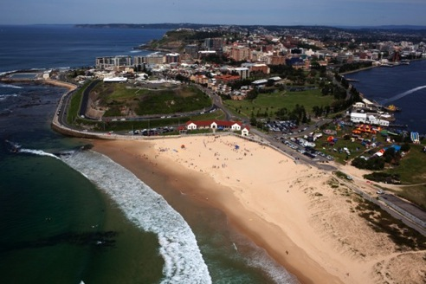

Aerial view of Nobbys Beach, Newcastle

# Conference Committees

The CAUTHE 2018 conference committees will oversee the operational, scientific, financial and marketing logistics of the conference and will comprise of the following individuals:

* Conference Convenor: Dr Tamara Young, Newcastle Business School
* Chair of the Scientific Committee: Professor Kevin Lyons, Newcastle Business School
* Conference Organiser: Kate Ramzan-Levy, Faculty of Business and Law
* Conference Planning Team: Dr Paul Stolk, Dr Patricia Johnson, Dr Anne Buchmann, Dr Po-Hsin Lai, A/Prof Frank Agbola, and Dr Jamie Carlson
* PhD Representative: Gary O’Dell
* ECR Representative: Dr Paul Stolk

The conference committee will be supported by a number of subcommittees including:

* Operations: logistics, finances, marketing and communication, volunteer management. This sub-committee will include academic and professional staff in the Faculty of Business and Law
* Scientific: conference program, papers and publications of the proceedings. This sub-committee will include academic staff from the Newcastle Business School and tourism colleagues at other universities.
* Industry sponsorship and industry engagement: facilitate integration with CAUTHE affiliates, state and local governments and industry associations. This sub-committee will include academic and professional staff in the Faculty of Business and Law.

# Conference Timing

Following the CAUTHE recommendation that the conference take place within the first two weeks of February, we propose that the 28th annual CAUTHE Conference is held from Monday 5th February to Thursday 8th February, 2018. This scheduling allows domestic participants to travel and attend the conference during the working week. This timing also falls outside of the University’s teaching semesters, leaving campus facilities free for conference use. The CAUTHE 2018 conference will commence with the PhD/ECR and MCA workshops on Monday 5th February and the main conference will run from Tuesday 6th February to Thursday 8th February 2018.

# Conference Theme

The proposed conference theme for CAUTHE 2018 is:

***Get Smart: Paradoxes and Possibilities in Tourism, Hospitality & Events***

It is 25 years since a small group of tourism and hospitality educators (THE) gathered at The University of Newcastle for a conference that was the precursor to the annual CAUTHE conferences. It would have been impossible to imagine back in the early 1990s how industrial cities, such as Newcastle, might adapt to a post-industrial world let alone establish services economies to attract tourists. Yet Newcastle, like many regional cities globally, have successfully negotiated this transition by getting smart about processes of renewal and creating quality services for both residents and visitors on the foundation of a knowledge economy.

CAUTHE 2018 will provide a forum to explore how the rapid development of easily accessible information is transforming the ways by which visitors and tourists behave. It will also provide a forum for considering how tourism, hospitality and events might capitalise on opportunities that emerge in a world where smart technologies produce large data sets that can provide detailed insights into tourist mobilities and behaviours.

The conference will consider changes that are occurring in the way future generations of tourism, hospitality and event professionals are developing their knowledge and expertise. CAUTHE 2018 will provide opportunities to share knowledge about how contemporary tourism, hospitality and event students learn, the various technologies that assist or hinder the learning process, and the role of educators in a context where information is only one click away.

At this conference we acknowledge that the process of building knowledge and becoming smart about tourism, hospitality and events can generate a series of paradoxes, ironies, and juxtapositions. Not only does new knowledge challenge conventions in tourism contexts, but alternative ways of knowing can disrupt how tourism, hospitality and events are developed and experienced.

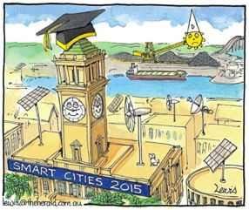

Planning to be a Smart City,

The Newcastle Herald, 1 October 2015, p.10

Potential topics that capture these juxtaposing dualities include:

* Rurality and urbanism in regional tourism destination development
* The co-existence of extractive industries and sustainable tourism in destinations
* Regulating the tourism sharing economy while deregulating small and medium tourism enterprises to encourage enterprise
* Outbound and inbound global mobility of youth – are they equal?
* Culturally sustainable Indigenous tourism in a world that uses a primarily global north perspective
* Volunteer tourism and the rise of a narcissistic generation
* Promoting sustainable tourism services to international tourists who need to travel long distances on high carbon emitting forms of transport
* A predominantly male senior academy with a largely female junior academy
* Slow tourism in an increasingly time pressured global workforce
* The possibility that smart technologies lead to a lack of deep thinking in tourists about sustainability?
* Dispassionate tourism scholarship with compassionate outcomes
* Continuity with change in tourism

Such topics will be explored through keynote presentations, plenaries, expert panel sessions, concurrent paper and poster presentations. Industry representatives from the Hunter region will play an integral role in the conference program.

CAUTHE Special Interest Groups (SIGS) will also be able to integrate within the conference theme and sub-themes and/or have a dedicated session streams committed to each special interest area.

# Inclusion and Accessibility

UON is committed to equity and social justice. Equity of access to higher education is strengthened by various initiatives aimed at increasing participation in education of students from low socio-economic and Indigenous backgrounds. The Centre of Excellence for Equity in Higher Education and the Wollotuka Institute for Indigenous Education provide equity initiatives that enhance the reputation of the UON as a global leader in evidence-based activities that enhance access to university. UON is the largest provider of enabling programs in Australia committed to developing pathways into higher education for students from diverse backgrounds.

The Wollotuka Institute, accredited by the World Indigenous Nations Higher Education Consortium, is committed to the advancement and leadership of Indigenous education at a local, national and global level. UON is a national leader in Aboriginal and Torres Strait Islander education, consistently achieving excellent levels of success comparative to the sector for Indigenous staff and student participation and outcomes. The Wollotuka Institute is informed by Cultural Standards developed in line with Aboriginal cultural values, principles and teachings.

In 2012, the Tourism Discipline in the Newcastle Business School was identified by the Wollotuka Institute as an institutional leader in Indigenous cultural competency, with our tourism courses having the most pervasive inclusion of Aboriginal and Torres Strait Islander content in the Newcastle Business School. The current Head of the Tourism Discipline is nationally recognised for evidence-based research on Indigenisation of curricula initiatives, and in partnership with the Dean of the Newcastle Business School, was awarded Higher Education Participation and Partnerships Program funding to develop Australia-wide strategies to increase Indigenous participation, success and retention in business higher education.

A comprehensive Celebration of Country by the campus Aboriginal Elder in Residence will take place during the conference opening ceremony. Indigenous participation in the conference will be facilitated by the well-established relationship between the Tourism Discipline and the Wollotuka Institute. A guest speaker from a local award-winning Indigenous tourism enterprise will deliver a presentation and an Indigenous tourism stream will be incorporated into the program.

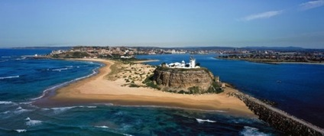

Nobby’s Head - Whibayganba

A sacred Awabakal site that recently gained dual name status

Gender equity will also be a major component of CAUTHE 2018. As lack of recognition and under‐representation of women in leadership roles are features of the tourism academy, equitable representation will be a key issue. Consequently, the Tourism Education Futures Initiative (TEFI) *Recommendations for promoting gender equity and balance in tourism conferences* will be adopted including:

* Gender equity in the committee structure and forefront in considerations of program content and session composition;
* Our commitment to thinking creatively to identify female scholars, making proactive choices, and encouraging participation to overcome gender bias;
* Recognising family values and facilitating arrangements to encourage female inclusion, (including access to child care);
* Gender/ethnicity respectful social programs; and
* Ensuring that our sponsors are made aware of our commitment to gender issues and our desire for limited use of gender stereotyping.

The conference and social venues will give due consideration to the accessibility requirements of presenters, participants, their travel companions, sponsors and exhibitors who may be aged or have a disability. Consequently, communication and seat allocation will be carefully considered to cater to the visually and hearing impaired. Consideration will also be given to:

* Allowing sufficient time for the less able to move between events;
* Providing clear signage;
* Providing assistance with the service of food and beverages;
* Special dietary requirements; and
* Access ensured to presentation/award platforms.

Accessible venues and accommodation will be sourced and accessible door-to-door transport provided where required. Disability awareness training will be arranged to ensure operational knowledge and awareness confidence.

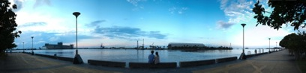

Newcastle Harbour

# Conference Venue: The University of Newcastle

**NeW Space City Precinct Campus**

We are bringing the 28th CAUTHE Conference to our newly revitalised NeW Space City Precinct Campus located in the heart of the Newcastle CBD.

NeW Space is a $95 million landmark education precinct under development by the University of Newcastle in the heart of Newcastle's CBD. The new precinct is a significant revitalisation project for the city of Newcastle and will host a range of University-supported activities including business and law programs, digital library services and information commons, collaborative learning and research spaces, facilities for engagement with industry, business and the community and social learning spaces.

The concept design for the University’s NeW Space education precinct creates an innovative, ‘vertical’ campus that is a gathering place for the University and for Newcastle – a place for creative exchange, for meeting, for enhancing the business of the city – as well as a great place for students and academics to learn and research.

An iconic landmark in our great city, the NeW Space concept is designed to be a place that invites the city and the community into the building, the University and onto the city campus through social spaces, connecting pathways and active student learning spaces that are right on the street front.

The design, which is contemporary and confident, strives to capture the University’s global outlook and aspirations. Connecting with the city are the building’s prominent views to the Newcastle Town Hall; and the series of double height ‘urban rooms’ or ‘look outs’ that are placed to take advantage of views of key Newcastle landmarks and inviting people to explore to the very top of the building.

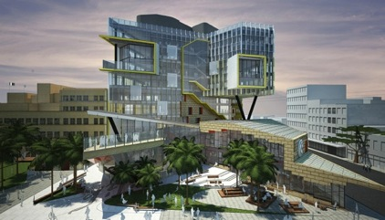

Artist’s impression of University of Newcastle NeW Space City Precinct Campus

Environmentally, NeW Space is focused on a sustainable design and is targeting 5 star Green Star rating, aligning with the University's sustainability objectives. To optimise the NeW Space learning experience, the project will focus on delivering indoor environments that enable exceptional research and student learning to be undertaken, including through natural ventilation. A dual directional sun shading system will wrap around the building form, and provide excellent sunlight protection specifically designed for each solar orientation.

Newcastle was the first Australian city to be included on the Lonely Planet’s ‘Top 10 Cities to Visit’ list in 2011. Newcastle sits uniquely between a working harbour and gorgeous ocean beaches. The city centre is home to over 3,000 businesses, which provide a wide array of restaurants, cafes and boutique shops for visits and residents to enjoy. There are also several historical landmarks and galleries and museums around the city.

There are numerous large venues within a few kilometres of NeW Space, which can accommodate large events. The Faculty of Business and Law regularly hosts events in the Newcastle Conservatorium, the historic Civic Theatre, and Newcastle City Hall is just next to NeW Space across from Civic Park.

# Conference Location: Newcastle

Nestled in the heart of the Hunter Region, a short two-hour drive north of Sydney, is the beachside city of Newcastle. Newcastle is a lively coastal town boasting a spectacular coastline, cosmopolitan cafes, award-winning restaurants, harbour side bars, a vibrant arts scene, and boutique shopping precincts. In recent years Newcastle has undergone a renaissance from steel city to a city that is world class, full of life and always changing.

In 2011, Newcastle was named a top ten city in the world in Lonely Planet's ‘Best in Travel' guide, and in 2012, 2014 and 2015 was a recipient of an International Festival and Events Association award for cities with a population of under one million. The city continues to flourish with internationally recognised events, industry and education. This was demonstrated when Newcastle played host to one of the most anticipated sporting events in the world, the AFC Asian Cup Australia 2015. Newcastle is committed to providing world-class conference and event experiences for organisers, delegates and spectators through its strong community spirit and 'can do' attitude.

Newcastle has been, and continues to be, a city in transition. As such, it is a city of paradox and possibility – where hard industry is gradually being superseded by soft industries fuelled by the knowledge economy, smart technologies, and growth in tourism, hospitality and event service sectors.

Newcastle is also considered to be the gateway to the stunning North Coast, including neighbouring Port Stephens, and to the natural wonders and gastronomic delights of the beautiful Hunter Valley.

# Transport and Transfers

Newcastle is located on the east coast of NSW, a short two-hour drive north of Sydney. Newcastle Airport is a 25 minute leisurely drive from the CBD of Newcastle and offers regular services to major cities including Melbourne, Sydney, Brisbane and the Gold Coast.

**Newcastle Airport**

Newcastle Airport is the fastest growing regional airport in Australia and offers direct daily flights to and from major cities including Sydney, Melbourne, Brisbane, The Gold Coast and Ballina. These cities provide a hub through to other destinations around Australia and the world.

**Carriers servicing Newcastle Airport**

Qantaslink; Virgin Australia; Jetstar; FlyPelican; Regional Express

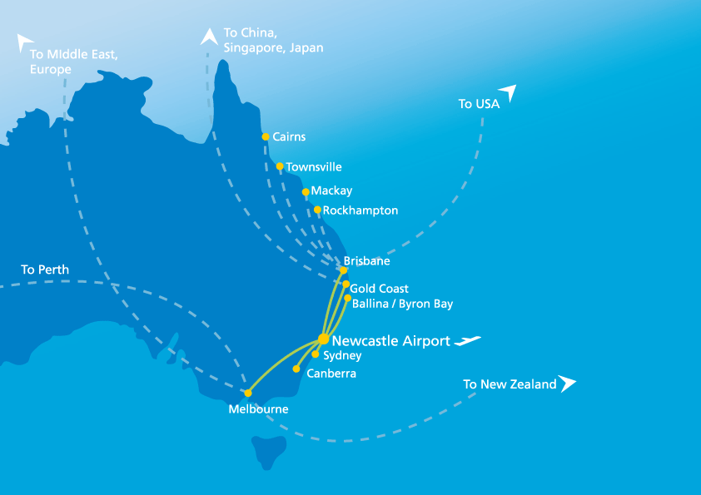

**Airport transfers**

Newcastle airport is located 15km north of Newcastle City with a range of transfer options to the venue and accommodation. The Newcastle Airport team is committed to providing a reliable, professional and prompt service. They specialise in conference and event transport and are dedicated to providing flexible transport arrangements to meet the needs of individuals and groups. Located in the arrivals terminal, the Newcastle Airport Information Services Desk is a one-stop-shop for all conference transfers.

**Buses**

Port Stephens Coaches operate a public bus service from Newcastle Airport to Newcastle train station up to 11 times each day.

**Trains**

Newcastle is connected by the CityRail network with multiple stations positioned around the City Centre. Frequent daily return services are available heading south on the Newcastle/Central Coast network with access to Lake Macquarie, the Central Coast, Sydney and surrounding suburbs and heading north west on the Hunter network providing access to the Lower and Upper Hunter regions. CountryLink trains connect Newcastle to Sydney, Brisbane and many other country centres.

**Rental cars**

Car rental services at Newcastle Airport are provided by Avis, Budget, Europcar, Hertz, Redspot, and Thrifty. Car rental desks are located inside the arrivals terminal.

**Taxis and Uber service**

Newcastle Airport's taxi rank is adjacent to the departures end of the terminal. Newcastle Taxis can be contacted directly, free-of-charge, on the dedicated taxi phone located in the terminal. Uber also operates from Newcastle Airport.

**Conference transfers**

During the course of the conference, a shuttle service will operate between accommodation providers and the main conference venue. Transfers will also be organised for delegates from the main conference venue or accommodation to venues included in the social program.

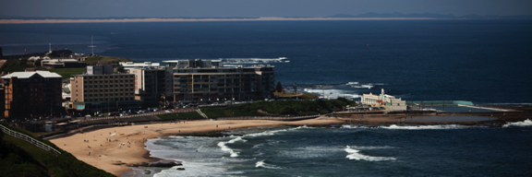

Newcastle Beach

# Accommodation

Newcastle offers a wide variety of accommodation options ranging from 4.5 star self-contained hotel options budget rooms in backpacker hostels or pubs. Below is a list of accommodation options located within close proximity to NeW Space City Precinct Campus. Most of these hotels are also within easy access to the fare free bus zone, which operates between 7:30am and 6:00pm Monday to Friday.

|  |  |  |
| --- | --- | --- |
| **Property Name** | **Website** | **Walking distance from NeW Space City Campus** |
| **Serviced Apartments** | | |
| Chifley Apartments Newcastle | [www.silverneedlehotels.com/chifley/newcastle-apartments](http://www.silverneedlehotels.com/chifley/newcastle-apartments) | 3 minutes |
| Crown Apartments on Darby | [www.crownondarby.com.au](http://www.crownondarby.com.au) | 5 minutes |
| Quest Serviced Apartments | [www.questapartments.com.au/Newcastle](http://www.questapartments.com.au/Newcastle) | 5 minutes |
| **Hotels** | | |
| Crowne Plaza Newcastle  (4.5 star) | [www.crowneplazanewcastle.com.au](http://www.crowneplazanewcastle.com.au) | 3 minutes |
| Novotel Newcastle Beach (4 star) | [www.novotelnewcastlebeach.com.au](http://www.novotelnewcastlebeach.com.au) | 15 minutes |
| Noahs on the Beach  (4 star) | [www.noahsonthebeach.com.au](http://www.noahsonthebeach.com.au) | 15 minutes |
| Travelodge Newcastle  (4 star) | [www.travelodgehotels.com.au/Newcastle](http://www.travelodgehotels.com.au/Newcastle) | 10 minutes |
| Hotel Ibis Newcastle (3.5 star) | <http://accorhotels.com.au/accommodation/newcastle-nsw/ibis-newcastle> | 5 minutes |
| Newcastle Beach Hotel  (3 star) | [www.newcastlebeachhotel.com.au](http://www.newcastlebeachhotel.com.au) | 15 minutes |
| **Pub-Style** | | |
| The Lucky Hotel  (Boutique) | [www.theluckyhotel.com.au](http://www.theluckyhotel.com.au) | 7 minutes |
| The Grand Hotel  (Boutique) | [www.thegrandhotel.net.au](http://www.thegrandhotel.net.au) | 15 minutes |
| **Backpacker Hostels** | | |
| Newcastle Beach  YHA | <https://www.yha.com.au/hostels/nsw/newcastle-surrounds/newcastle-beach/> | 15 minutes |
| Backpackers by the Beach | [www.backpackersbythebeach.com.au](http://www.backpackersbythebeach.com.au) | 15 minutes |

# Attractions and Activities

Perfectly nestled between the pristine waterways and national parks of Port Stephens and culinary delights and beauty of the Hunter Valley, Newcastle is ideally located to provide a wide range of activities, attractions and excursions for both delegates and partners of CAUTHE 2018.

We will provide a range of tailored itineraries for delegates to book prior to or post the conference to extend their stay within Newcastle and the Hunter Region. Examples of the many attractions and activities are provided below.

**Attractions**

**Cuisine**

Even better than seeing and feeling the change in Newcastle, is tasting it. A new generation of chefs have transformed Newcastle into a hot dining destination. On the streets, there are lively little tapas bars, wine bars, coffee roasters, and a plethora of fine dining treats with a fresh twist and without the 'big city' attitude.

**Art Culture**

Dubbed Australia's new Arts Capital by CNN Travel, Newcastle has one of the greatest numbers of artists (as a percentage of the population) of any city in Australia so it is not surprising that the Arts scene is thriving. In this transformed city, creative pursuits are encouraged and artistic flair celebrated. Treat yourself and visit the cluster of galleries and boutiques along Darby Street, Newcastle East and Cooks Hill.

**The Outdoors**

There are few cities in the world that can say that their city centre is surrounded by six stunning beaches. Ride the wave of surfing culture that characterises the city and join the locals for an early morning dip. Swim in the art deco Newcastle Ocean Baths (opened in 1922) and have fish and chips at the Canoe Pool, built in the late 1930s for young swimmers. Look out for whales and dolphins, a common sight off Newcastle's beaches. Enjoy historical walks around the city or get back to nature along our coastline or in our parks and reserves.

**Activities**

**Newcastle**

**Hunter to Harbour History Tour**Enjoy Devonshire tea as you explore Newcastle Harbour before heading up the iconic Hunter River with NOVA Cruises. Marvel at the dramatically changing landscape from city hustle and industrial harbour to the serenity of the Kooragang Wetlands. Tour includes lunch at the Hunter Wetlands Centre and a guided tour of Newcastle Museum.

**Newcastle Art Gallery Tour**

Every weekend, the Gallery runs free guided tours of current exhibitions for the public. Hosted by volunteer Gallery Guides, the tours last about one hour and provide a glimpse into contemporary and historical art practice.

**Bathers Way Walk**Stretching from the commanding lighthouse at Nobby's Headland to the coastal wilderness of Glenrock reserve and the early coal workings at Burwood Beach, Newcastle's Bathers' Way is a 5km scenic coastal walk that takes in Newcastle's Indigenous and convict heritage, culture and natural history.

**East End History Walk**This tour is perfect for those who love history and are after a walking tour that takes in the oldest streets of Newcastle.

**Newcastle Scenic Pub Tours**Enjoy spectacular views of Newcastle beaches, the harbour and nearby Lake Macquarie with a 5 hour tour of some of the magnificent waterfront venues in the area.

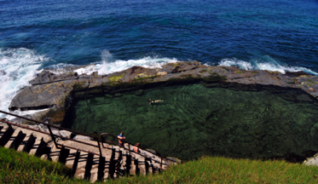

Newcastle Bogey Hole

**Port Stephens**

**Port Stephens 4WD Tours**Take an adventure on the largest moving sand dunes in the Southern Hemisphere. Port Stephens 4WD Tours offer a range of options from a one hour discovery tour including sand boarding to Sygna Shipwreck Tours.

**Moonshadow Cruises**Moonshadow Cruisesis an award-winning cruise business with three vessels equipped with boom nets, waterslide, hydrophones, underwater video cameras, spacious decks and licensed bars. Daily dolphin watch cruises are available (option for buffet lunch).

**Sand Dune Adventures**Sand Dune Adventures seeks to give clients a ‘hands-on and interactive’ insight into the richness of Aboriginal culture and heritage all the while providing clients with the exhilaration of riding a 400cc Quad Bike, guided by our experienced Aboriginal guides.

**Irukandji Shark and Ray Encounters**Experience the true nature of sharks, rays and the weird and wonderful world of the ocean.

**Hunter Valley Wine Country**

**Hunter Valley Gardens**Nestled in the heart of the Hunter vineyards are 25 hectares of spectacular display gardens with over 8km of walking paths.

**Divine Tours Pty Ltd**Join a Gourmet Wine Tour offering private tastings at 4-5 premium wineries, a 'behind the scenes' winery tour and lunch at an award winning restaurant. The tour also includes a Hunter Valley chocolate tasting and tasting of local cheeses.

**Balloon Aloft**Balloon Aloft are renowned for delivering the highest quality balloon flights and service. With unparalleled experience, your comfort and safety are assured.

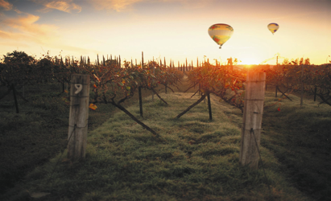

Hunter Valley Wine Country

# Conference Program

The conference program will consist of keynote plenary sessions, panel sessions, concurrent sessions, workshops, poster and virtual presentation sessions, and the great debate. Potential keynote speakers will be invited to speak about a range of topics related to the theme of smart tourism and the ambiguities associated with the tourism knowledge economy.

In keeping with the Tourism Discipline’s longstanding engagement with local business and industry, representatives from the local and regional tourism, hospitality and events industries will be invited to attend CAUTHE 2018 to engage with the latest tourism research. The conference aims to focus on topics of interest and relevance to industry and government. Accordingly, the conference will be promoted to industry and local government will their representatives will be invited to participate in panel discussions.

|  |  |  |
| --- | --- | --- |
| Day | Time | Activity |
| Monday 5 February | Full Day | PhD/ECR Workshops |
|  | Afternoon | MCA Workshop |
|  | Evening | Registration and Welcome Drinks |
| Tuesday 6 February | Morning | Conference Opening  Celebration of Country  Keynote Plenary Session  Concurrent Sessions |
|  | Afternoon | Concurrent Sessions  Special Interest Group Meetings  Publishers Presentations |
|  | Evening | Welcome Reception |
| Wednesday 7 February | Morning | Chapter Directors Breakfast  Concurrent Sessions |
|  | Afternoon | Concurrent Sessions |
|  | Evening | Free Evening with Dine Around Options |
| Thursday 8 February | Morning | Concurrent Sessions |
|  | Afternoon | The Great Debate  Conference Closing Ceremony |
|  | Evening | Conference Gala Dinner |

The conference will commence with a formal opening, a Celebration of Country, and keynote addresses to establish the scope of the conference and raise broad issues. Panel discussion will follow, reflecting on points made by the Keynote Speaker, and providing background to concurrent sessions and the theme for the conference. The panel will include government and industry representatives to outline future plans for tourism research. Speakers at concurrent sessions could include academics and industry experts who have published widely or have presented internationally on themes relevant to the conference. Virtual presentations will enable those who cannot attend the conference to present using the latest technology.

The Great Debate will be held on Thursday afternoon. A current topic related to the conference theme will be debated by opposing teams of four attending academics to be identified at a later date.

**PhD and Early Career Researcher Workshop**

The annual Bill Faulkner PhD Scholar and ECR workshop for scholars undertaking research on tourism and hospitality will be held on Monday 5th February. The conference committee will work with CAUTHE to provide the necessary logistical support together with morning tea, lunch and afternoon tea.

The anticipated cost of the workshop will be $50 for delegates attending the conference, and $100 for those scholars attending the workshop only. It is anticipated that approximately 50 participants will attend together with approximately 20 academics. The session will end with drinks and an informal BBQ to provide networking opportunities for participants and conference delegates who have arrived on Monday.

**Mid-Career Academic Workshop**

The biennial MCA workshop will be held on Monday 5th February, prior to the conference and will be organised in liaison with the CAUTHE Executive committee. A meeting room equipped with AV projection suitable for 50 people will be provided. The anticipated cost will be $20 For conference participants and $20 for academics attending the workshop only.

**CAUTHE Business**

The conference will also host other meetings as part of the conference program and will provide appropriate meeting spaces. These meetings include:

* CAUTHE Annual General Meeting
* Chapter Directors’ Meeting (immediately following the AGM)
* Chapter Directors Breakfast

The conference convenor will liaise with the secretariat to schedule these meetings.

**Special Interest Group Streams**

Special interest groups will be developed and coordinated with the assistance of CAUTHE providing an opportunity for interested researchers to discuss their research and create future research collaborations. The SIG members will be provided an opportunity to meet during the conference.

SIGs will be afforded two opportunities to convene within the conference:

* A two-hour session to coordinate a call for papers from their SIG members & other interested researchers
* Another two-hour session for general SIG discussions

CAUTHE currently supports 8 SIGs, thus 2 SIG sessions with 4 SIGs in each is planned. Scheduling will consider CAUTHE members who are involved in more than one SIG.

**Social Events**

As the conference provides the major social event in the academic calendar, an extensive social program is scheduled. For example:

* Informal welcome drinks for delegates who arrive on the Monday.
* A welcome reception.
* A gala dinner at the conclusion of the conference.
* Designated areas and times for networking throughout the conference.
* A series of morning teas, lunches and afternoon teas.
* Designated bar/lounge area for after-hours social engagement.

It is anticipated that Merewether Surf House will provide a stunning gala dinner location where guests can enjoy a social experience overlooking Merewether Beach.

**CAUTHE Awards**

The following awards will be organised and presented at the conference dinner:

* CAUTHE award for Best Full Paper
* The Bill Faulkner award for Best PhD Paper
* CAUTHE award for Best Poster
* CAUTHE Fellows award for Outstanding Contribution to Tourism and Hospitality Education and/or Research
* CAUTHE travel bursary award winners (PhD and ECR)

The scientific committee will review nominated papers and posters before granting awards for Best Full Paper, Best PhD Paper and Best Poster. Awards not only recognise the achievements of delegates but integrate conference sponsors by integrating awards such as books etc.

**Conference Papers**

The CAUTHE conference website and key e-mail lists will be used to issue the call for papers soon after the completion of CAUTHE 2017. Submission guidelines for refereed full papers and non-refereed working papers and abstracts will also be issued at this time.

**Virtual Attendance**

Video conferencing and virtual attendance will be available for interested parties who are unable to attend the conference in person.

With ongoing technological advances in communication systems and software, virtual attendance at conferences has become a legitimate option for those delegates who – for whatever reason – are incapable of in-person attendance. Enabling virtual attendance expands the reach of the conference and provides opportunities for ‘blended’ interactivity, whereby virtual attendees can engage with conference content, presentations, workshops, keynote speeches, other virtual attendees, and, most notably, those delegates physically present at the conference.

A multi-dimensional virtual event platform will be used for the 2018 conference, so that the benefits commonly associated with face-to-face conferencing – such as meeting new people, networking, and interacting with exhibits – will also be accessible to virtual attendees. To facilitate interactivity between virtual and ‘real’ delegates, in-person attendees will be encouraged to use personal laptop computers and portable devices in order to access the event platform during the conference.

The virtual event platform will include a digital library of all relevant files and resources, interactive discussion boards and chat windows, and real-time (or on-demand) audio and/or video streaming of selected sessions. The use of the NeW Space campus precinct for the concurrent presentation sessions is a pivotal component of the platform’s capability, as the technology-enabled teaching rooms will feature the latest interactive presentation hardware and software.

Virtual attendance and the virtual platform also constitute key parts of post-conference evaluation. Both are mediums that produce an ‘electronic footprint’ composed of a variety of data, and this data can be used to develop evaluative analytics that are otherwise difficult to generate from traditional evaluation data collected in-person at conference events. For example, analytics from the virtual attendees might draw on the electronic records of the sessions attendees watched or interacted with, the resources they downloaded, the number and nature of virtual conversations initiated.

It is anticipated that the cost of virtual participant attendance will be $110.00 per session.

**Building Attendee Engagement**

The methods for engaging conference delegates at the 2018 CAUTHE conference will apply two experiential foci: personalisation and connectivity. Both foci will be facilitated by electronic platforms and the use of digital media. For both strategic and operational planning purposes, delegate engagement will be split across the event lifecycle into distinct pre-conference, mid-conference and post-conference phases.

The central pillar for attendee engagement, across all phases of the event, will be a bespoke conference website. The website will be designed to be scalable for ease of use across a range of electronic devices, including PCs, laptops, tablets and mobile phones. The website will be the central mechanism for:

* A personalised delegate registration system (with options for both CAUTHE membership renewal & new CAUTHE membership);
* A customisable conference itinerary-builder for all plenary, sessional, workshop and social activities;
* An electronic file repository for submission of working paper abstracts, full papers, and other conference outputs;
* Delegate access to key conference resources, such as proceedings, key note speeches and sponsor offers; and
* The virtual conference event interface proposed in the previous section.

In conjunction with the website functionality described above, all three conference engagement phases will incorporate an email marketing and communication component to promote conference event information, correspond with registered attendees and presenters, and to solicit post-event feedback. Established e-mail ‘communities’ in the tourism and hospitality field, such as TRI-net, will be particularly important to the promotional and attendee recruitment efforts.

Social media – specifically Twitter, LinkedIn and Facebook – will supplement the website platform and email communication. Pre-conference use of social media will assist with raising awareness of the event as well as providing specific ‘calls to action’, such as providing links to the website registration portal.

The ‘real-time’ integration of social media as part of conference activities will promote engagement with an audience that reaches beyond the (actual and virtual) conference attendees. This kind of wider engagement is particularly important if the key debates and issues generated within the conference are to have an impact beyond the academy, to connect with industry or public stakeholders. For example, the development and promotion of a conference and event-specific ‘hashtag’ will mean that the content of tweets or LinkedIn/Facebook posts extend beyond those attending, thus opening engagement to anyone following the hashtag or even happening upon tweets or posts made by the social media accounts they follow.

**Evaluation**

A proven evaluation technology platform will be used to analyse the various conference components and its success by collecting in-depth data on participant profile information, participants’ expectations and satisfaction, and overall qualitative comments. The survey results will thus provide critical feedback to reflect on this conference and improve future conferences.

# Environmental Impacts

The University of Newcastle is committed to making the conference as sustainable as possible and will communicate this to stakeholders. Environmental considerations include:

* The NeW Space campus is a sustainable design and is targeting 5 star Green Star rating, aligning with the University's sustainability objectives. To optimise the NeW Space learning experience, the project will focus on delivering indoor environments that enable exceptional research and student learning to be undertaken, including through natural ventilation. A dual directional sun shading system will wrap around the building form, and provide excellent sunlight protection specifically designed for each solar orientation.
* Engaging local suppliers committed to sustainable practices including packaging, reusable tablecloths, cutlery, glasses etc.
* Engaging local venues with policies to minimise carbon footprint, use of local goods, locally owned, employs locals, EEO, recycling.
* Electronic registration and marketing.
* Employ electronic communication for information exchange where possible, for example, the submission of papers and reviewer feedback.
* Use of recyclable name badges.

# Finance and Administration

The Faculty of Business and Law will be responsible for the organisation, financing and marketing of the conference, with the full support of the UON. The Faculty guarantees that the organising committee has delegated funds to ensure that the conference will proceed. A conference account will be established into which all payments can be made online. This account will be linked directly to the conference website.

**Income**

The major sources of income include registration fees, exhibition fees and sponsorship donations.

**Registration and Attendance Fees**

|  |  |  |
| --- | --- | --- |
| **Registration Type** | **CAUTHE Member $** | **Non-member $** |
| Early Bird rates | 800 | 920 |
| Early bird Student rates | 450 | 510 |
| Full Standard | 900 | 1020 |
| Full standard student rates | 500 | 560 |
| One day rates: Early bird | 300 | 340 |
| One day rates: Standard | 340 | 380 |
| One day rates: Student | 200 | 220 |
| **PhD ECR Attendance** |  |  |
| Workshop only | 100 | 100 |
| Workshop & conference | 50 | 50 |
| **MCA Attendance** |  |  |
| Workshop only | 20 | 20 |
| Workshop & conference | 20 | 20 |
| Social events only | 80 | 110 |
| Notes on fee setting: CAUTHE bid guidance suggests registration fees for non-CAUTHE members to be set higher than CAUTHE members by at least the cost of annual membership, which is $110 for full membership, and $55 for student membership. Obviously, such an approach is advocated in order to inventivise purchase of CAUTHE membership. With this in mind, as shown in the table above the registration fees for early bird and standard classifications have been set at a $120 gap for non-CAUTHE members compared to members, and at a $60 gap for non-CAUTHE student members compared to members. | | |
|

**Anticipated Attendance - Aspirational**

|  |  |  |  |
| --- | --- | --- | --- |
| **Attendance Type** | **CAUTHE Member** | **Non-member** | **Unique Attendees** |
| Early Bird | 77 | 26 | **103** |
| Early bird Student | 38 | 21 | **59** |
| Full Standard | 24 | 8 | **32** |
| Full standard student | 4 | 7 | **10** |
| One day Early bird | 6 | 13 | **19** |
| One day Standard | 6 | 12 | **18** |
| One day Student | 8 |  | **8** |
| **Sub-total** |  |  | **249** |
| **PhD ECR Attendance** |  |  |  |
| Workshop only | 6 |  | **6** |
| Workshop & conference | 50 |  |  |
| **MCA Attendance** |  |  |  |
| Workshop only | 0 |  |  |
| Workshop & conference | 10 |  |  |
| Social events only | 5 |  | **5** |
| Exhibitor, Complimentary, Volunteer | |  | **20** |
|  |  | **Grand Total** | **280** |

**Anticipated Attendance - Conservative**

|  |  |  |  |
| --- | --- | --- | --- |
| **Attendance Type** | **CAUTHE Member** | **Non-member** | **Unique Attendees** |
| Early Bird | 61 | 20 | **81** |
| Early bird Student | 30 | 16 | **47** |
| Full Standard | 19 | 6 | **25** |
| Full standard student | 3 | 6 | **9** |
| One day Early bird | 5 | 10 | **15** |
| One day Standard | 5 | 9 | **14** |
| One day Student | 6 |  | **6** |
| **Sub-total** |  |  | **198** |
| **PhD ECR Attendance** |  |  |  |
| Workshop only | 6 |  | **6** |
| Workshop & conference | 40 |  |  |
| **MCA Attendance** |  |  |  |
| Workshop only | 0 |  |  |
| Workshop & conference | 8 |  |  |
| Social events only | 4 |  | **4** |
| Exhibitor, Complimentary, Volunteer | |  | **15** |
|  |  | **Grand Total** | **222** |

**Sponsorship**

The conference organising committee will seek sponsorship from a number of organisations, including:

* Government agencies (TRA, RET, Tourism Australia, Destination NSW, Newcastle City Council, NSW Office of Environment & Heritage, NSW Department of Industry, Lake Macquarie City Council, Port Stephens City Council)
* Industry Associations (Newcastle Tourism Industry Group, Newcastle NOW, Hunter Valley Wine & Tourism Association, NSW Business Chamber, Newcastle Chapter of the AHA, GreenPower, AECOM, Eighteen04).
* Sponsorship from Newcastle businesses and industry groups such as Newcastle Port Corporation, Newcastle Airport, Hunter stadium, Crowne Plaza Hotel, Accor hotel Group, Moonshadow Cruises, Inter-city Winemakers.
* Educational Organisations (THE-ICE, NSW Universities such as UTS, Southern Cross University and Western Sydney University, The Tom Farrell Institute for the Environment, and The Hunter Environmental Institute).
* Existing partnerships held by UON and Newcastle Business School.

Sponsorship packages will be developed similar to previous CAUTHE conferences and will range from platinum, gold, silver and bronze sponsors. We will also arrange in-kind support such as gifts, awards, refreshment break costs, lunches and dinner costs and conference materials such as bags, pens, notepads and souvenirs.

The Sponsorship and Industry Engagement conference sub-committee will accordingly seek sponsorship and industry engagement. Based on past conferences, we estimate approximately $13,000 cash and in kind sponsorship will be generated.

**Exhibitions**

Publishers, such as Channel View Publications, Taylor & Francis, Elsevier, Wiley & Sons, Emerald, Goodfellow Publishers, and specific journals related to the conference theme, will be invited to display their publications at the conference and be given the opportunity to present at an allocated session. Display areas for other sponsor organisations will be provided. Exhibition income is estimated to $15,000.

# Conference Budget

The expenditure excludes the conference venue costs (contributed in-kind by the Faculty of Business and Law). PCO costs have been identified and will be provided by a conference organiser within the Faculty of Business and Law. Costs will be kept to a minimum to keep registration fees reasonable and therefore ensure maximum participation. CAUTHE membership fees collected as part of the registration and will be passed back to CAUTHE at the completion of the conference. A payment of $25 per delegate will be provided to CAUTHE as a name levy. The expenditure includes 5% allowance for contingencies and price increases. Based on the aspirational and conservative attendee figures calculated above, we have developed two budgets.

|  |  |
| --- | --- |
| **2018 Conference Budget – Aspirational (n=281; full delegates=135)** | |
| **Total Income** | **194,880** |
| All conference registrations | 162,930 |
| PhD/ECR workshop | 3,100 |
| MCA workshop | 250 |
| Partner/spouse social events tickets | 600 |
| Sponsorship (cash & in kind) | 13,000 |
| Exhibition (6 Publishers @ $2500 each) | 15,000 |
| **Total Expenses** | **182,767** |
| CAUTHE name Levy (62 Registrants @ $25) | 1,550 |
| Conference Dinner (300 incl. VIP & sponsors) | 25,830 |
| Welcome reception and BBQ | 11,480 |
| Entertainment | 6,458 |
| Conference catering | 46,494 |
| Transport | 5,023 |
| Speakers’ cost reimbursement, speakers’ gifts | 10,263 |
| Name badges, Delegates satchels | 1,220 |
| Admin costs – committee, paper admin expenses | 1,230 |
| Sponsorship & Exhibition Prospectus | 1,025 |
| Promotional materials | 2,050 |
| Public relations and promotion | 1,537 |
| Destination collateral & information booth | 1,537 |
| Website & registration | 3,280 |
| Program & book of abstracts (USB only) | 574 |
| IT support, video streaming and recording | 30,422 |
| Dissemination of papers | 1,794 |
| Contingency (5%) | 6,000 |
| PCO fees | 25,000 |
| Conference Venue Costs | TBC |

|  |  |
| --- | --- |
| **2018 Conference Budget – Conservative (n=222; full delegates=106)** | |
| **Total Income** | **151,330** |
| All conference registrations | 120,050 |
| PhD/ECR workshop | 2,600 |
| MCA workshop | 200 |
| Partner/spouse social events tickets | 480 |
| Sponsorship (cash & in kind) | 13,000 |
| Exhibition (6 Publishers @ $2500 each) | 15,000 |
| **Total Expenses** | **151,104** |
| CAUTHE name Levy (62 Registrants @ $25) | 2,650 |
| Conference Dinner (300 incl. VIP & sponsors) | 15,240 |
| Welcome reception and BBQ | 9,020 |
| Entertainment | 5,074 |
| Conference catering | 36,531 |
| Transport | 3,946 |
| Speakers’ cost reimbursement, speakers’ gifts | 10,263 |
| Name badges, Delegates satchels | 958 |
| Admin costs – committee, paper admin expenses | 1,230 |
| Sponsorship & Exhibition Prospectus | 1,025 |
| Promotional materials | 2,050 |
| Public relations and promotion | 1,537 |
| Destination collateral & information booth | 1,537 |
| Website & registration | 3,280 |
| Program & book of abstracts (USB only) | 451 |
| IT support, video streaming and recording | 29,903 |
| Dissemination of papers | 1,409 |
| Contingency (5%) | 6,000 |
| PCO fees | 25,000 |
| Conference Venue Costs | TBC |

# Promotion and Website

A website dedicated to the 2018 conference will be developed and linked to the main CAUTHE website. The 2018 conference website will contain links to registration, CAUTHE membership renewal/application and to the paper management system. UON will establish the domain [www.UON.edu.au/cauthe2018](http://www.uon.edu.au/cauthe2018) and establish a special email address for enquiries: [cauthe2018@UON.edu.au](mailto:cauthe2018@uon.edu.au)

The target markets for attendance are:

* Australian and international academics from institutions featuring tourism and hospitality courses.
* Postgraduate students researching and studying tourism and hospitality.
* Industry and government representatives from Australia. A dedicated industry seminar will be promoted to encourage representation from academia, industry and government to facilitate participation, discussions and knowledge exchange between these three key groups involved in tourism, hospitality and events.

Potential conference participants will be targeted from the CAUTHE membership database, and past CAUTHE conference attendees. Invitations will be emailed to key academics and Chapter university members and will be channelled through tourism industry networks, associations, and business chambers, many of whom are identified as sponsors to the conference. Invitations will also be sent to government agencies and other industry related bodies who hold an interest in the development of tourism, hospitality and events sectors (such as Meetings and Events Australian (MEA) and the Australian Hotel Association).

Marketing will commence with a promotional video at the closing ceremony of the 2017 conference in Dunedin, New Zealand. Promotion flyers will also be included in the 2017 conference satchels. After the conclusion of the 2017 conference, promotion will primarily be via the CAUTHE website, the CAUTHE Facebook page, the CAUTHE 2018 conference website, CAUTHE email lists, CAUTHE newsletters and other email lists of targeted prospective participants. The UON and Newcastle Business School’s internal marketing resources will assist to produce additional promotional material.

The organising committee of CAUTHE 2018 will develop a publicity program involving radio interviews and special interest media stories on speakers and topical issues. Media releases and associated interviews will be produced by the UON’s internal media resources.

# Registration and Attendee Management

**Management and registration systems**

Registration and participant management systems will ensure the timely, efficient, personalised collection and storage of all attendee details. The automatic pre-population of previous registration data will streamline the process. Registration confirmations, changes, cancellations, pre-event announcements, and automated email communications will be generated on a convenient user-friendly online system.

The system will also cater for secure payment of conference and CAUTHE membership fees. Registration will include options for delegates to indicate their intention to attend catered social functions, even if the price is included in the registration fee. New CAUTHE members will be able to join as part of the registration process, including the application of appropriate conference discounts OR will be able to access a direct link to the CAUTHE website for direct payment of membership fees, if preferred.

Integrated reporting and data management tools will be utilised to track attendance and fee management with remote access for organisers enabling real-time management of updates, correspondence, amendments and announcements.

**Academic paper management**

Electronic paper management systems will be utilised in keeping with UON sustainability principles. The systems will cater for:

* Paper submissions.
* Communication with reviewers.
* Paper approvals/rejections/feedback.
* Communication with authors.

Full papers will be double blind peer reviewed while the authors of working papers and abstracts will receive constructive and positive feedback. Email will be the preferred avenue of communication with scholars to reduce the conference’s ecological footprint. Full paper authors will be advised of the outcome of their submission as soon as possible to allow them to make travel arrangements.

Accepted authors will be required to supply consent forms which assign copyright to CAUTHE. The conference proceedings will be assigned an ISBN number.

Papers will be published on USB drives and made available to delegates on arrival at the conference.

**Visitor information and conference support**

A trained tourism student volunteer cohort will attend a visitor information desk and provide conference support during the conference.

# Timeline: Steps and Milestones

|  |  |
| --- | --- |
| Date | Activity |
| 18 July 2016 | Draft bid to CAUTHE Executive. |
| 29 July 2016 | Final bid to CAUTHE Secretariat. |
| 5 August 2016 | Conference bid presented at CAUTHE mid-year meeting. |
| September 2016 | Committees start work; develop initial working budget, secure quotes from suppliers and venues. |
| October 2016 | Develop theming, logo and marketing resources; book conference venue and room blocks; book social activities venues. |
| November 2016 | Develop sponsorship packages and commence communication with potential sponsors; develop exhibitors’ packages and commence communication with potential exhibitors. |
| December 2016 | Refine marketing and operational planning; identify entertainment; develop web-based and printed marketing materials; finalise draft program. |
| January 2017 | Finalise flyers for distribution at CAUTHE 2017 conference. |
| February 2017 | Formally launch CAUTHE 2018 conference and make website live. |
| March 2017 | Commence CAUTHE 2018 communication campaign; communicate paper deadlines; confirm keynote speakers; invite VIPs. |
| July 2017 | Finalise sponsorship; confirm trade exhibitors; report progress at CAUTHE mid-year meeting. CAUTHE travel bursaries applications open. |
| August 2017 | First call for papers; open early bird registrations. |
| September 2017 | Final call for papers; finalisation of referee list; promotion of ECR/PhD workshop; CAUTHE travel bursaries applications close; confirm speakers and VIPs. |
| October 2017 | Final acceptance of refereed papers. |
| November 2017 | Final acceptance of working papers. |
| December 2017 | Recheck all suppliers and venues; develop template for proceedings; close submissions of final papers; finalise conference program; recruit and train student volunteers. |
| January 2018 | Finalise conference proceedings; confirm trade exhibitors’ display needs; source thank you gifts for speakers. |
| February 2018 | Conference delivery; handover; final payments. |
| March 2018 | Thank you letters to speakers, VIPs; finalise conference report. |
| July 2018 | Conference report to CAUTHE AGM. |

# Contact

For further information about this bid document, please contact:

Dr Tamara Young

Lecturer in Tourism, Head of the Tourism Discipline

Newcastle Business School, Faculty of Business and Law

The University of Newcastle, Australia

T: +61 2 4921 5804

F: +61 2 4921 6911

E: [tamara.young@newcastle.edu.au](mailto:tamara.young@newcastle.edu.au)