SOUTHERN GOLD COAST ACCOMMODATION OPTIONS (SELECT)

CAUTHE MYM 15-16 July 2019

Mantra Coolangatta Beach

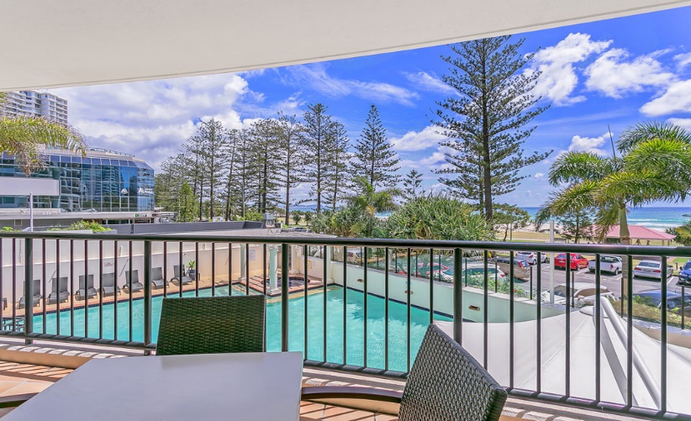
88 Marine Parade, Coolangatta, QLD
1, 2 and 3 bedroom Apartments + Studio Suites
Directly across from beach

Mantra Twin Towns (Coolangatta/Tweed)

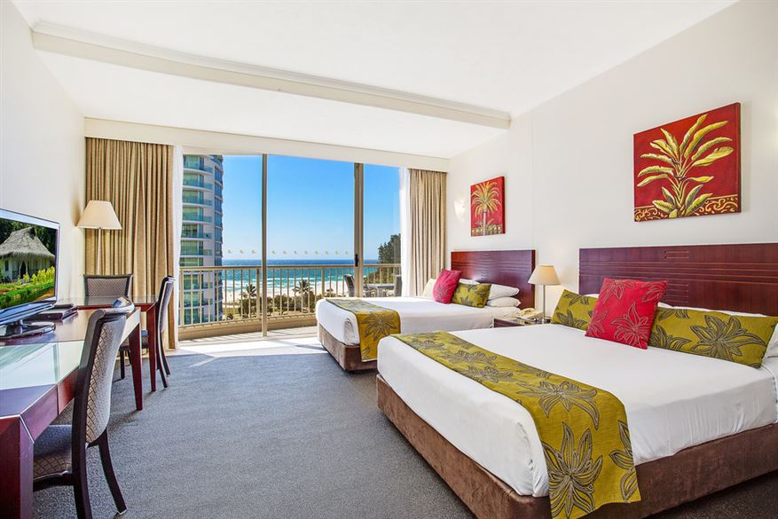
Corner Griffith & Wharf Street, Tweed Heads, NSW
Suites, Hotel Rooms and Apartments
1 block back from Coolangatta Beach.

Oaks Calypso Plaza (Coolangatta)

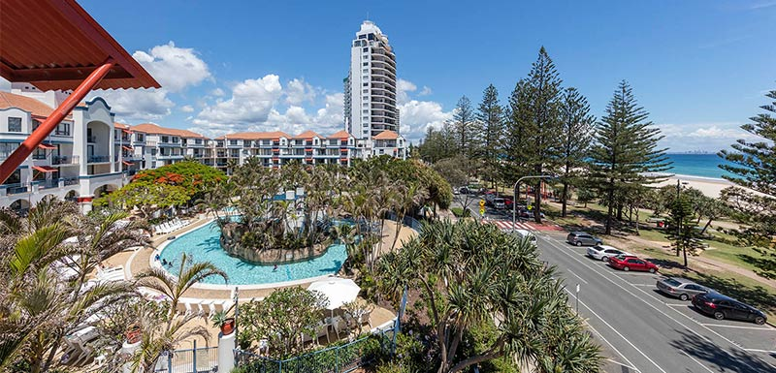
99 Griffith Street, Coolangatta, QLD
1 and 2 bedroom apartments
Directly across from beach.

Iconic Kirra Beach Resort

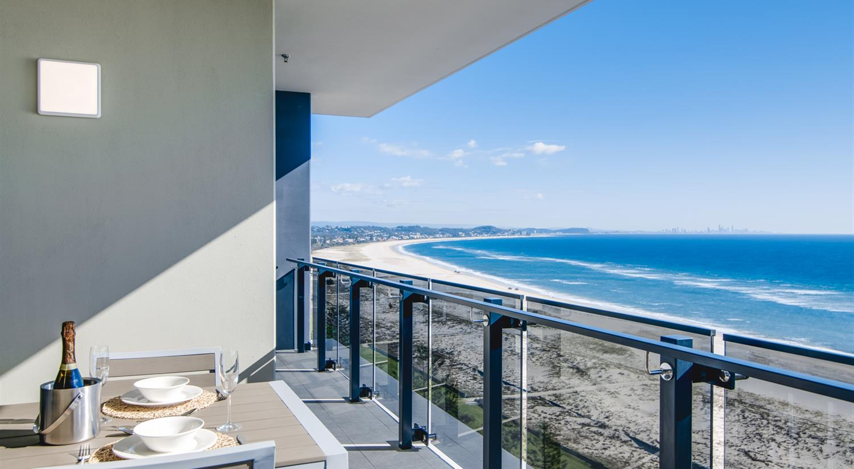
76 Musgrave Street, Kirra, QLD
1, 2 and 3 bedroom apartments + Studios
Directly across from Kirra Beach

Kirra Surf Apartments

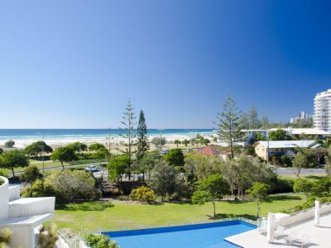

6-8 Creek Street, Kirra/Bilinga
1, 2 and 3 bedroom apartments/penthouses + Ground Flour apts
Closest to SCU Campus; directly across from Kirra Beach.

Coolangatta-Kirra YHA

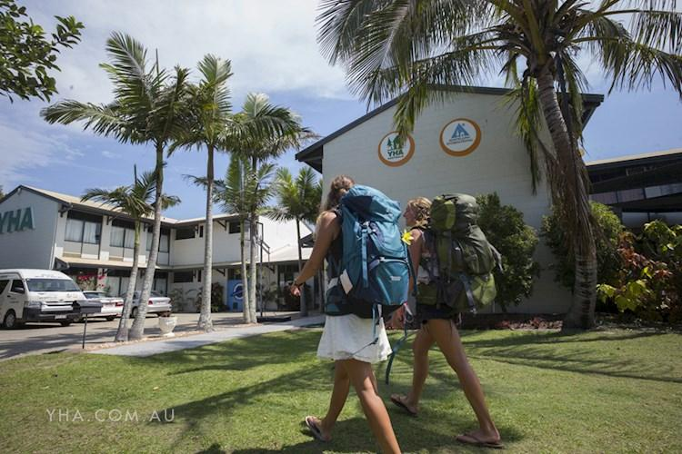

230 Coolangatta Road, Bilinga, QLD
Backpacker-Hostel style accommodation
Close to beach.

Greenmount Beach Hotel

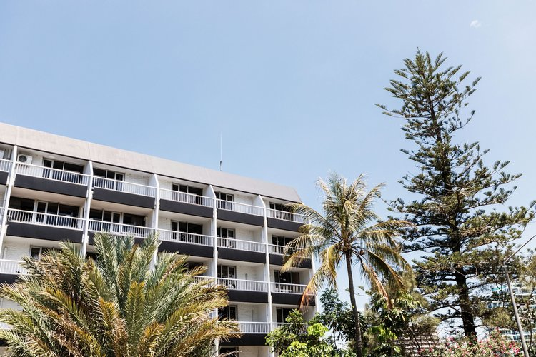

3 Hill Street, Coolangatta, QLD (Rainbow Bay)
Directly across from Rainbow Bay Beach.

