Teaching and Learning Special Interest Group information

To help you with your scholarship of teaching and with your S2IG endeavours, here below are some resources and information which may guide and support you.

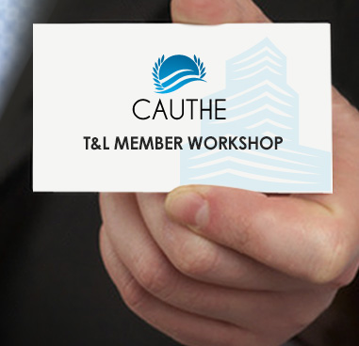

If you wish to consider starting a scholarship of teaching and learning (SoTL) project with the aim of getting presentations and publications out there, look here and for more resources, here.

Consider particularly the section ‘designing and beginning’ your project.

Also, you will need to consider the depth of your project: do you wish to explore your chosen issue further to form theory in a new or under-investigated topic (exploratory or inductive research) or do you have an idea or relationship you want to test, whereby you form hypotheses and collect evidence to test (confirmatory or deductive research). You could also decide to follow through with a longer-term research agenda.

Methodological considerations for your project can be explored at this link.

If you want or need to consider journal rankings / impact factors, you can search rankings of education journals here; and tourism / hospitality / events / sports / recreation journals here. You can download an Excel spreadsheet and search for journals / subject areas / title words as well.
Of course publishing a paper (working paper or full paper) at a CAUTHE conference is an excellent aim. One of the benefits of CAUTHE is that unlike some, it allows you to re-publish your paper with a journal later (as long as you acknowledge that an earlier version of your paper was presented at CAUTHE).

A good network to get involved in (especially for your Sustainable tourism / SDG group members):

TEFI: Tourism Education Futures Initiative: a social movement comprised of educators, researchers, industry actors and community members, who seek to progress an alternative type of tourism that is sustainable and just, that delivers blended social, economic and environmental value, and that promotes vibrant flourishing communities.
http://tourismeducationfutures.org/

Here below are some more publication outlets.

Generic scholarship of teaching

HERDSA: Higher Education Research and Development Society of Australasia. Q1 … journal, conferences, SIGs and more.
http://www.herdsa.org.au/

Teaching in Higher Education (also Q1)
http://www.tandfonline.com/toc/cthe20/current

JoSoTL: Journal of the Scholarship of Teaching and Learning
https://josotl.indiana.edu/.

JUTLP: The Journal of University Teaching and Learning Practice
http://ro.uow.edu.au/jutlp/

Journal of Student Success (formerly the International Journal of the First Year in Higher Education). The journal themes align with the STARS ethos (Students, Transitions, Achievement, Retention and Success) and with the STARS annual conference
Conference: http://unistars.org/
Journal: https://studentsuccessjournal.org/

Tourism, Hospitality, Events (etc) education focused

JoHLSTE Journal of hospitality leisure sport and tourism education (Q2)
https://www.journals.elsevier.com/journal-of-hospitality-leisure-sport-and-tourism-education-johlste/ This is the highest-ranking T&L-focused journal in our own subject area.

Journal of Teaching in Travel and Tourism: the professional journal of the International Society of Travel & Tourism Educators (ISTTE). (Q3)
https://www.istte.org/journal.html
http://www.tandfonline.com/toc/wttt20/current

JHTE: Journal of Hospitality and Tourism Education (Q3)
http://www.tandfonline.com/toc/uhat20/current

JHTC: Journal of Hospitality and Tourism Cases is an international refereed electronic journal (e-journal) published by ICHRIE.
https://www.chrie.org/i4a/pages/index.cfm?pageid=3333

Teaching with technologies: Multiple journals - extensive list here:
https://educationaltechnology.net/educational-technology-journals-peer-reviewed/

I hope some of this information is useful to you and I look forward to seeing you at CAUTHE.

Kindest regards
Mieke

Dr Mieke Witsel, PhD, Drs., MA
Co-chair, CAUTHE Teaching and Learning Special Interest Group
School Director of Teaching and Learning
International exchange coordinator
School of Business and Tourism
M 0439 719 808
E mieke.witsel@scu.edu.au
LISMORE CAMPUS
Room: R2-19
PO Box 157 Lismore NSW 2480

